Rapid Implementation Framework for the GBEP Sustainability Indicators for Bioenergy: Handbook
December, 2021

Acknowledgements

This Handbook was prepared by Andrea Rossi and Constance Miller, with the support of Tiziana Pirelli and under the overall supervision of Maria Michela Morese, GBEP Executive Secretary and FAO Natural Resource Officer. It was prepared in the framework of the FAO project “International Alliance for Climate Smart Agriculture - IACSA” (GCP/GLO/534/ITA), which was funded by the Italian Ministry of Ecological Transition (MITE) and implemented by the FAO Office of Climate Change, Biodiversity and Environment (OCB) under the coordination of Federica Matteoli (FAO), Natural Resources Officer, with Tiziana Pirelli as Lead Technical Consultant.
The authors are grateful to Marco Colangeli and Lorenzo Traverso of the GBEP team for their help in formulating the concept for the Rapid Implementation. The authors would also like to thank all GBEP Partners and Observers who provided inputs to the work, especially Olivier Dubois (FAO) and Maria Murmis (Argentina) for their detailed feedback on initial drafts.
1 | INTRODUCTION
AIM
This Chapter sets the background for the RIF, providing information on resource requirements, stakeholder engagement and the steps in the process.

Background
In December 2011, the Global Bioenergy Partnership (GBEP) agreed upon a set of 24 indicators for the assessment and monitoring of bioenergy sustainability. Each of the 24 indicators includes a short description and a multi-page methodology sheet that outlines the approach for collecting and analysing data, highlights data limitations and provides additional references to other well-documented processes.
Since their adoption, the GBEP indicators have been implemented in fourteen countries, spanning four continents. On the basis of the lessons learned from the implementation of the indicators, an Implementation Guide was published in 2020. This document provides methodological guidance for each of the 24 indicators, addressing a number of related practical issues as well.
The measurement of GBEP sustainability indicators for bioenergy may require significant resources (both human and financial) and tends to be data- and capacity-intensive. The publication of the Implementation Guide represents an important step in aiding countries with the implementation of these indicators. However, to advance their uptake, it is important to further facilitate a less resource-intensive measurement of the GBEP indicators, especially in case of limited data and capacity.

Scope and objectives.
This Rapid Implementation Framework (RIF) aims to complement the Implementation Guide, by supporting and expediting the operationalization of selected working packages included in it. In particular, the RIF allows users to conduct an evidence-based prioritization of the GBEP indicators. This means that within six months, it should be possible to carry out a rapid measurement of the critical GBEP indicators and obtain a preliminary indication of likely impacts on sustainability from the most relevant bioenergy pathways in the country/region considered.

Target users, resource requirements and stakeholder engagement.
The RIF is intended mainly for practitioners interested in conducting a rapid assessment of the sustainability of the bioenergy sector and/or specific bioenergy pathways in their country or region, using the GBEP indicators. The results of this six-month process provide a preliminary indication of likely impacts on sustainability, and information on where more in-depth assessment is required due to large, critical and/or unmeasurable impacts. For a more thorough assessment of these impacts, the full methodologies described in the indicator report should be used.
The RIF can be used flexibly depending on country context. The intention is that the RIF is conducted as a (series of) multi-stakeholder meetings. However, the questionnaires provided in this handbook can be responded to in a group format or individually, with the results being later compiled.
As explained in the Implementation Guide, among the overarching practices for an effective implementation of the GBEP indicators, users should seek to encourage the proactive engagement of all relevant stakeholders including government agencies, private sector organizations, academic/research institutions and civil society organizations. This is particularly important in the context of a rapid implementation of the GBEP indicators. The questions included under the various steps that comprise the RIF should be addressed to selected producer associations (including biomass suppliers) and to a multidisciplinary group of experts with an in-depth knowledge of:
- The national/local context, particularly in terms of environmental and socio-economic characteristics/conditions and related vulnerabilities;
- The domestic agricultural and forestry sectors and related markets; and
- The domestic bioenergy sector and related technologies, logistics and policies.
Ideally, feedback should be sought as well from a sample of end-users, including both households and businesses, especially in relation to off-grid power applications and small-scale cooking and heating systems. In order to answer the questions, information and data available in national and international databases may be used, combined with expert judgement. In some cases, ballpark estimates based on experience will be necessary. Sources of information should be clearly stated.
The table below – an excerpt from the Implementation Guide – includes the list of public, private and multilateral stakeholders to be engaged.
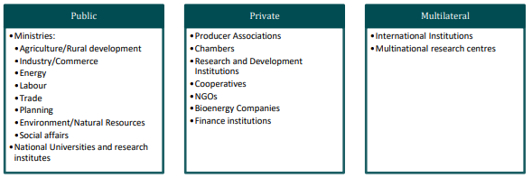

Rapid Implementation steps.
The Rapid Implementation Framework provides relevant guidance and materials to be followed for the rapid implementation of the indicators:
- Description of Institutional Context and Regulatory Framework [Chapter 2].
- Selection of Most Relevant Bioenergy Pathways [Chapter 3].
- Exclusion of Non-Applicable GBEP Indicators [Chapter 4].
- Value Chain Description and Identification of Critical GBEP Indicators [Chapter 5].
- Visualization of Results of Prioritization of GBEP indicators [Chapter 6].
- Monitoring of safeguards and good practices relevant for critical GBEP indicators [Chapter 7].
The flowchart below shows gives a visual overview of the steps involved in the rapid implementation.
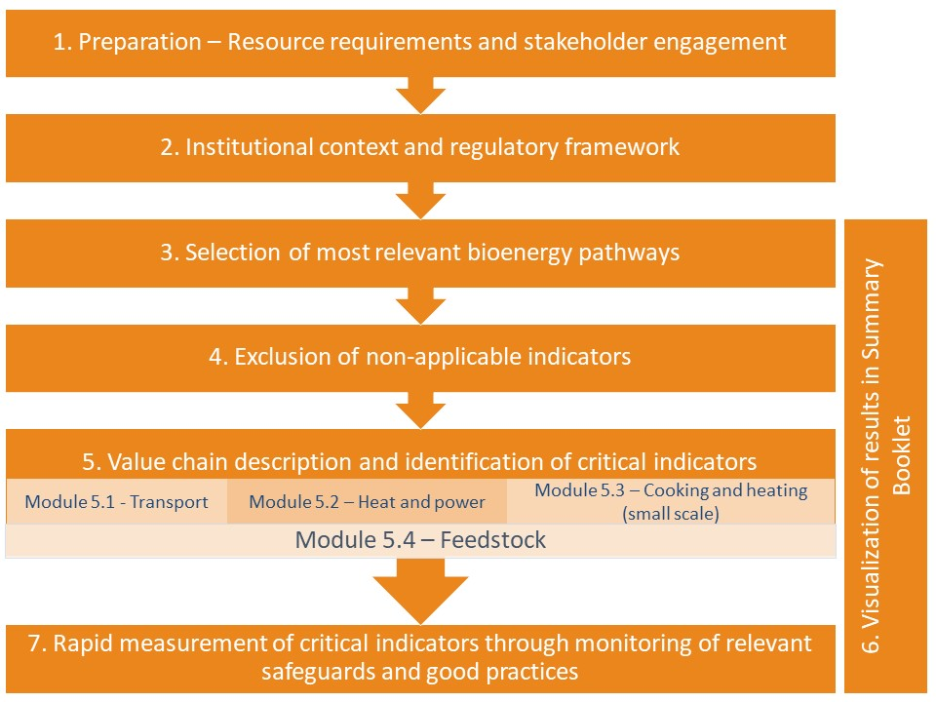
Chapter 2 (Description of Institutional Context and Regulatory Framework) comprises a questionnaire addressing the following issues:
- Policy-making process;
- Bioenergy targets/mandates and incentives; and
- Drivers/objectives and sustainability requirements of bioenergy policies.
Based on the latter, a preliminary list of critical GBEP indicators is generated, which are the minimum that would be required to monitor the identified sustainability priorities of the bioenergy policies. As explained below, additional critical GBEP indicators are further identified in Chapter 5 (Value Chain Description and Identification of Critical GBEP Indicators).
In Chapter 3, guidance is offered on the selection of the most relevant bioenergy pathways for analysis, and a few possible selection criteria are suggested.
Once the most relevant bioenergy pathways have been identified, the next stage of the RIF aims to identify the critical indicators to measure and monitor based on the sustainability risks of the particular pathway(s). As a first step, in Chapter 4, a list of non-applicable GBEP indicators and sub-indicators is provided, depending on the selected bioenergy pathway(s).
Chapter 5 includes a questionnaire that aims to help users:
- generate a description of the value chains associated with the selected bioenergy pathway(s); and
- identify critical GBEP indicators, based on the main characteristics of such value chain(s) and likely impacts on sustainability.
This Chapter consists of four modules, which should be approached as follows:

Compulsory (i.e. relevant to all bioenergy pathways): | To be filled in depending on the selected bioenergy pathway(s) and end uses:
Module 5.4 – Feedstock production and harvest | Module 5.1 – Transport  Module 5.2 – Heat and Power  Module 5.3 – Cooking and heating (small-scale)

The questions in this Chapter are grouped into different categories, depending on:
- the origin of the biofuel;
- the type(s) and origin of the feedstock used; and
- the types of fuels and technologies that were displaced, if any.
Based on the answers to these questions and on the environmental and socio-economic characteristics/conditions and related vulnerabilities in the country/area considered, a list of critical GBEP indicators (in addition to those already identified in Chapter 2) is generated.
In parallel with this process, the identified critical GBEP indicators from both Chapter 2 and Chapter 5 should be included in the supplementary Summary Booklet available in Chapter 6 (Visualization of Results of Prioritization of GBEP indicators). There, a table is provided where each factor that contributed to the selection of the critical indicators for the bioenergy pathway can be noted for future ease of reference.
Finally, Chapter 7 aims to support the rapid measurement of the critical GBEP indicators. In particular, guidance is provided on the monitoring of the level (and quality) of implementation of relevant safeguards and good practices that can mitigate risks and increase benefits in relation to the sustainability dimensions addressed by the GBEP indicators. Please see Box 1 for a more detailed discussion on this.

WHERE TO?
Finished this Chapter?
Go to Chapter 2 “Description of institutional context and regulatory framework”.
Box 1 – Safeguards and good practices for sustainable bioenergy: the Climate-Smart Agriculture approach
The monitoring of the level of uptake – and its change over time – of climate-smart agriculture (CSA) practices, along with other safeguards and good practices, can provide a preliminary indication of the sustainability of biomass supply.
Some of the main objectives of CSA are to sustainably increase agricultural productivity and to reduce GHG emissions, whilst adapting and building resilience to climate change. These are also objectives that are important for the production of feedstock for sustainable bioenergy production. This approach is therefore beneficial to mainstream into bioenergy systems. There are two cases where this approach could be applied:
- Sustainable production of dedicated biomass, for example, in the adoption of practices that improve the sustainability of production such as conservation agriculture, intercropping, crop rotation, integrated pest management, etc.; and
- Improving the sustainability of food systems with the use of residues and/or wastes, from either production and processing of agricultural products and residues, or from food loss and waste at the end of the value chain. Examples of approaches could include the circular use of wastewater, alternative uses of crop residues to avoid burning, and circular use of nutrients and carbon stock.
The CSA approach also includes the integration of bioenergy into farming systems to improve their sustainability. In fact, when bioenergy is integrated into farming systems it can enhance their efficiency, provide additional source of income through product diversification, increase access to modern energy and reduce impacts of agriculture on climate change. Furthermore, the bioenergy by-products can also be used as an additional source of energy or returned to the soil to recycle nutrients and also capture and store carbon. This means that the capacity of the farming system to adapt to and mitigate climate change is improved. So the use of bioenergy in farming systems can ultimately increase the sustainability of agri-food value chains, and improve livelihoods and food security.
A more detailed list of CSA practices and a discussion of their impacts on sustainability can be found in Chapter 7.

